**MARKET BASKET INSIGHTS**

**TEAM MEMBER**

810021106036: K.KANIKARAN

PHASE 2: INNOVATION

**PROJECT DEFINITION:**

Market basket insights is a data mining technique for identifying purchase patterns in any retail environment. Market basket insights is a set of statistical affinity calculations that highlight purchasing patterns to help business leaders better understand – and ultimately serve – their customers. Market basket insights, in its most basic form, searches for the most common product combinations in transactions.

Simply put, Market basket insights is a data mining technique that allows a store owner to analyze and determine product combinations, which items are related, and which items customers frequently purchase together. It’s a lovely strategy based on the basic principle that if we buy something, we’re obligated to buy or avoid something else (or a bunch of things).

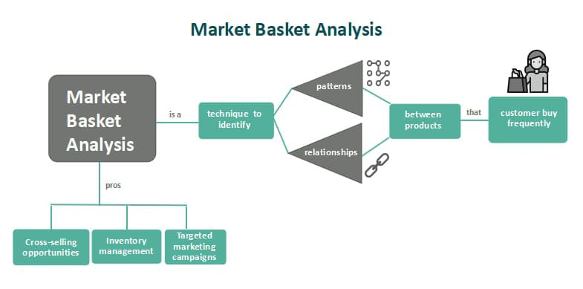

In order to achieve the highest turnover, we want the customer to buy as much as possible.

The one of the ways to make the customer to buy the product is to suggest them more products.

**What is the best product to propose to the customer?**

* Market basket insights/analysis is the best way to suggest products for the customer.
* The retailers use to increase sales by better understanding customer purchasing patterns.

**What does the market basket insights/analysis do?**

* If a customer will buy product A if she/he already has product B in their shopping cart.
* The market basket analysis gives the analysis of which product is good and which is often bought by other customers.

**Product placement:**

Finding products that are frequently purchased together and strategically placing them near each other to encourage customers to buy both. This placement can be physical, such as product placement on shelves in a physical store, or virtual, such as in a print catalogue or on an e-commerce site.

**Point-of-Sale:**

Companies may use the affinity grouping of multiple products as evidence that customers are likely to buy certain sets of products at the same time. When certain products are bundled together, this allows for cross-selling or suggests that customers might be willing to buy more.

**Customer Retention:**

When customers contact a company to end a relationship, a representative from the company may use market basket analysis in data mining to determine the best incentives to offer in order to keep the customer’s business.

**EXAMPLES**:

Retail market uses a well-known example of market basket insights. They are under the headings of "Frequently bought together" and "Customers who bought this item also bought."

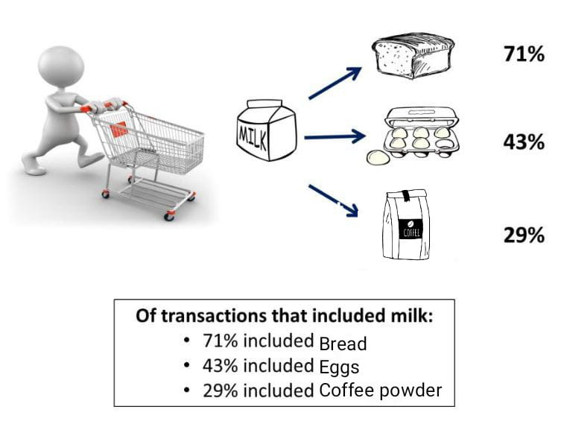

If a customer buys milks there may be a chance that he/she will buy eggs, bread or coffee powder and this is called market basket insights.

The retailers will come to know by the purchase of previous customers.

To calculate a shopping cart insight, you need a list of past purchases, where you can see which products were bought together in one purchase.

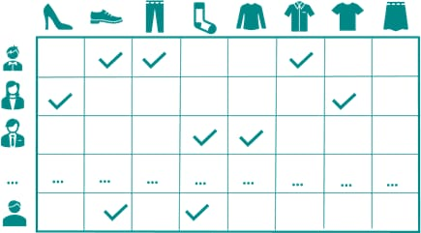

so you have the respective products listed and each row is a transaction. Let's say that is your example data, you have the products jeans, shirt, jacket and shoes.

market basket analysis sample data:

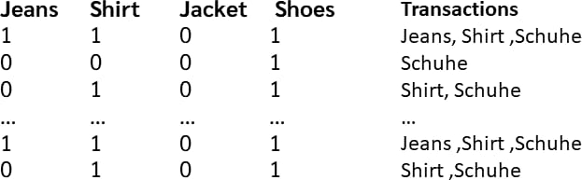

Each row is a transaction or a purchase. 1 means bought, 0 means not bought. So the first person bought jeans, shirt and shoes.

Now, so that we have results that we can interpret.

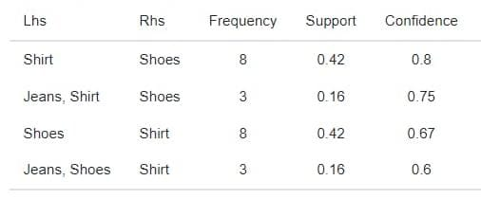

Now we can specify a minimum support and a minimum confidence.

**CALCULATION OF DESIGN COMPONENTS:**

* Frequency
* Support
* Confidence

**Frequency:**

The frequency in the results table tells us how often the products under LHS and RHS occur in a transaction.

**Frequency=frequency (LHS, RHS)**

**Support:**

Support tells us what percentage of all transactions that is, or in other words, how likely it is that the combination of products will occur in a transaction. we just divide it by the frequency by the number of all transactions.

**support=frequency (LHS, RHS)**

**N**

**N=number of transactions**

**Confidence:**

Confidence now tells us, if the products under LHS are in an order, how likely it is that the products under RHS are then also in the shopping cart.

**Confidence=frequency (LHS, RHS)**

**frequency (LHS)**

**MARKET BASKET INSIGHTS INTERPRET RESULTS:**

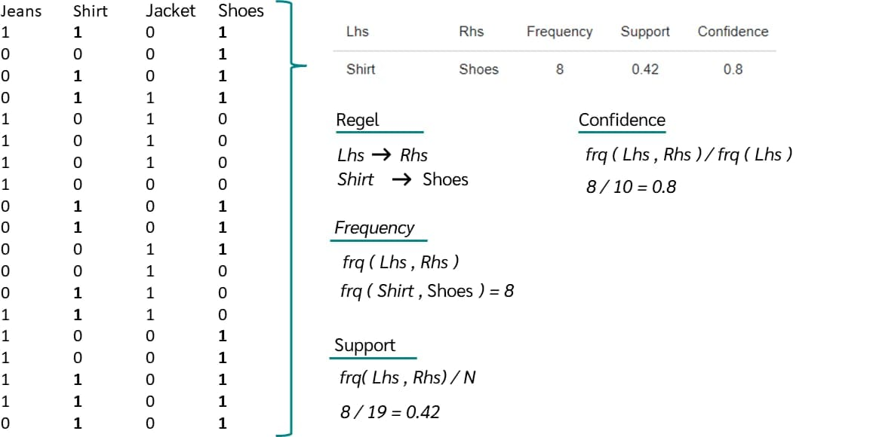

* In this case, how often does shirt and shoes occur in a transaction.so let's just count through how many transactions both occur in, which is 8 transactions.
* 19 transactions we have in total, so we get 8/19, which is equal to 0.42. so the probability of shirt and shoes occurring in a transaction is 42 percent.
* if shirt occurs in the cart, then shoes are also in the cart. We can calculate this by dividing the frequency of shirt and shoes by the frequency of shirt. In this case the probability will be 80 percent.

**MORE IS THE SUPPORT**

**MORE IS THE CONFIDENCE**